ISLE OF DOGS
LONDON

Distance: 7 km (4.3 miles)
Difficulty: Easy
Terrain: Urban footpath
Height gain: 70 metres
Map: OS Explorer 162
Starting point: Canary Wharf River Bus Stop (GR TQ 369 804; what3words hands.gasp.putty)

Highlights
- The best views in London
- Walking beside the mighty Thames
- Fascinating history throughout
- London Docklands and Museum
Pubs and cafes near the route
- The Gun
- The Hubub
- The Ferry House Inn
Dogs
- Welcome
Isle of Dogs: Circular walk

Directions
- Start at the Canary Wharf River Bus stop and walk east along the Thames Path. The Isle of Dogs is reached via the metal footbridge over the remnants of The City Canal to Limehouse Lock. After a kilometre or so of walking through the colourful residential areas strung along the river the Sir John McDougal Gardens offer the first play space for kids and a picnic spot. Historically built to allow public access to the river, when huge flour mills dominated the foreshore, it was designed to make the most of the expansive views of the Thames.
- Continue along the Thames path with a short but interesting detour inland along Westferry Road passed the Docklands Sailing Centre with its historical twin cranes and on to the curious façade of St Paul’s. Known as The Space, this is one of London’s most important buildings. Built for the Scottish Presbyterian dockers it is now a centre for the performing arts with a café bar, The Hubub, serving good food and coffee.
- Pass through the arches of a small residential area, to return to the river. At Millwall, flour mills were built along the walls of the Thames. This is also the site that the SS Great Eastern, the largest ship of its time, was launched sideways into the Thames. A section of the launch site is preserved at the modern Napier Avenue. Slightly further along is Burrells Wharf, once an important trading centre for chemicals, paints, drugs and oils and now a smart residential complex. The brick chimney used by the colour-makers often belched out pink smoke that left the local pigeons with pink tinted feathers. A few steps on and it’s well worth pausing to pick out the famous landmarks across the river at Greenwich – the glass dome at the south entrance of the foot tunnel, the wooden masts of the Cutty Sark, the majestic buildings of Greenwich Hospital and the parkland with the Royal Observatory on the hill top all contribute to one of the most famous views of London.
- Pass The Ferry House Inn, the oldest building on the island, close to the old ferry crossing to Greenwich and once catered for the men that regularly crossed the river between the two points to graze and fatten up their horses and cattle on the pastures of the Isle.
- A short distance further on and the Island Gardens provide a lovely green space, a strong sense of community and the northern access point to the Greenwich tunnel – a mighty engineering feat for its time and Victorian architectural delight if you decide to walk through it. The Gardens were built to improve the views from well-heeled Greenwich over to the Isle of Dogs. Although there is an outdoor café here there is also the option of exploring Mudshute Park and Farm. Just north of Island Gardens and the largest city farm in Europe there are thirteen hectares of open space, a medley of farm animals and a café. Clues to the origins of the site can be interpreted in its name; the overspill from excavating Millwall Dock was dumped here through a chute system.
- After the gardens the Thames path rounds the southern tip of the island and continues north past the rather uninspiring Great Eastern Pub. On the south side of the Thames the skyline is dominated by the yellow-strutted O2 Centre and the helter-skelter of the Emirates Air Line cable car spanning the river between Greenwich in the south and the Royal Docks in the north. The river traffic eases off on this stretch of the Thames. Just the superfast Clipper boats that skim the surface of the water and the river barges on their way to recycling what the City doesn’t need. There is a lot more bird life here and, if you are lucky, you may see seals and maybe even a porpoise.
- Follow the diversions inland to avoid housing estates and building projects before the brightly coloured pagoda-like building of Outrums pumping station makes for quite a surprise as you rejoin the river. Grade II listed this is the first listing to come out of Historic England’s Post-Modernism project. Don’t be deceived by its unusual design though it’s a workhorse during periods of heavy or prolonged rain when the main sewer network fills up and pumps excess water directly to the River Thames to prevent flooding.
- Reach the eastern end of the old City Canal and cross the A1206 to South Quay and Canary Wharf’s towering, angular buildings with their colourful and reflective surfaces. The walk is then completed by crossing Marsh Road and rejoining the tideway at Lime House Lock.

There are circular routes around 50 islands of Britain featured in our book “Islandeering: adventures around the edge of Britain’s hidden islands”.

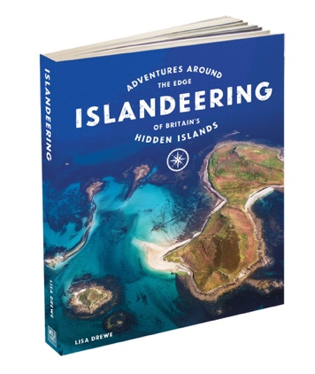
Happy Islandeering
Lisa, Charlie and Goose
www.islandeering.com

