BEDRUTHEN STEPS
CORNWALL

Distance: 3.5 km (2.2 miles)
Difficulty: easy-moderate
Terrain: South West Coast Path; tidal beach; easy scramble
Height gain: 214 metres
Map: OS Explorer 106
Starting point: National Trust Carnewas car park (GR SW 849 690)

Highlights
- Stunning cliff top views of all islands (sea stacks of Bedruthen)
- Amazing wildlife in the rock pools of Porth Mear
- Optional descent onto the incredible Bedruthen beach to bathe in the pools around the stacks
- Optional extension to swim in the beautiful lagoon of Trescore Islands
Pubs and cafes near the route
- Carnewas Tearooms
Dogs
- Welcome on the beach and paths
Bedruthen Steps: Circular walk
Bedruthen Steps offers some of the most spectacular coastal scenery in Britain. At low tide there is a beach with golden sands and turquoise sea water pools that sit invitingly around the bases of its dramatic sea stacks, whilst at high tide it becomes a seething mass of Atlantic waves pounding the rugged cliffs. This circular walk includes stunning views of the islands of Bedruthen from the high cliffs of the South West Coast Path, as well as an optional low tide walk along Bedruthen beach, with the further option of extending the route to swim in the beautiful low-tide lagoon between the Trescore Islands and the mainland, just north of Porth Mear Cove. The return route heads inland, before a final stretch along the coast path.

Directions
- From the National Trust Carnewas car park head directly to the coast and pick up the South West Coast Path heading NNE. After 500 metres, for an optional descent to walk the length of Bedruthen beach, take the steps down to the beach (for current state of repair and access to the steps, always check first https://www.nationaltrust.org.uk/carnewas-at-bedruthan ). If you do not plan to descend to the beach, then continue along the coast path, and resume the route at 3.
- Walk north along the beach passed the various sea stacks to reach the Pentire Steps. There are two options for scrambling back up to the South West Coast Path. At the north end of the beach, north of Diggory’s Island, there is an easy short scramble onto a path to The Viewpoint (as marked on Google Earth). The alternative route from the same beach, is a short scramble on to a path that leads up to Pentire Steps. This can be accessed via the cliffs about half way along the bay.
- Once back on the South West Coast Path, continue to Park Head, then around to the foot bridge at Porth Mear Cove.
(To swim in the sheltered waters inland from the Trescore Islands, continue over the footbridge and head north, until you are almost parallel with the southerly point of the islands and there are routes down the cliff, to reach good points to launch for a swim)
- The return route, from Porth Meat Cove keeps to the west (right) of the stream as you head inland (south) and the path continues to Porth Mear Cottage and Pentire Farm. Once on the lane turn left towards the National Trust car park at Park Head and , just as you reach it take the footpath to the right for 180 metres, then turn left and return to the coast path at Pentire Steps. Turn left and return to the car park.

There are circular routes around 50 islands of Britain featured in our book “Islandeering: adventures around the edge of Britain’s hidden islands”.

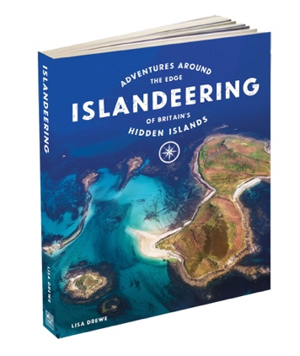
Happy Islandeering
Lisa, Charlie and Goose
www.islandeering.com

